A

Project Report

is

Submitted to the completion of Epam-COE-DevOPS

Training Program

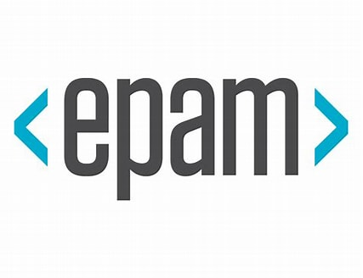

Submitted By:

Ms. Priyanka Bhardwaj

Junior Software Engineer-Epam Hyderabad

**Task- 2 Infrastructure as Code Using Terraform (Modules)**

